

**QGIS Lab Series**

**GST 102: Spatial Analysis**

**Lab 7: Raster Data Analysis - Working with Topographic Data**

**Objective – Learn the Basics of Terrain Analysis**

**Document Version:** **2014-07-22 (Final)**

**Author:**

Kurt Menke, GISP



**Contents**

1 Introduction 2

2 Objective: Learn the Basics of Terrain Analysis 2

3 How Best to Use Video Walk Through with this Lab 2

Task 1 Terrain Analysis 2

Task 2 Reclassification 10

Task 3 Raster Calculator 13

5 Conclusion 15

6 Discussion Questions 16

7 Challenge Assignment 16

1. Introduction

In this lab, you will learn about topographic data and how to use it for analysis. You will learn how to create datasets such as slope, hillshades using QGIS Desktop. You will then learn how to combine them using raster algebra.

This lab includes the following tasks:

Task 1 Terrain Analysis

Task 2 Reclassification

Task 3 Raster Calculator

1. Objective: Learn the Basics of Terrain Analysis

The objective of this lab is to learn the basics of terrain analysis using QGIS Desktop.

1. How Best to Use Video Walk Through with this Lab

To aid in your completion of this lab, each lab task has an associated video that demonstrates how to complete the task. The intent of these videos is to help you move forward if you become stuck on a step in a task, or you wish to visually see every step required to complete the tasks.

We recommend that you do not watch the videos before you attempt the tasks. The reasoning for this is that while you are learning the software and searching for buttons, menus, etc…, you will better remember where these items are and, perhaps, discover other features along the way. With that being said, please use the videos in the way that will best facilitate your learning and successful completion of this lab.

1. Terrain Analysis

In this task, you will use a digital elevation model to create several terrain related datasets: slope, aspect and hillshade. These elevation derived datasets can be important in site selection and other terrain based spatial analyses.

1. The data for this lab is located on the lab machine at: *C:\GST102\Lab 7\Data.*
2. **Open QGIS Desktop 2.4.0.**
3. **Add** the **35106-B4.dem** raster to **QGIS Desktop** using the **Add Raster Layer**  button. This raster layer has elevation values for each cell. This type of data is referred to as a digital elevation model, or DEM, for short. This particular dataset covers the Sandia Mountains on the east side of Albuquerque, New Mexico (**Figure 1**). The light areas have the highest elevation and the dark areas the lowest elevation.

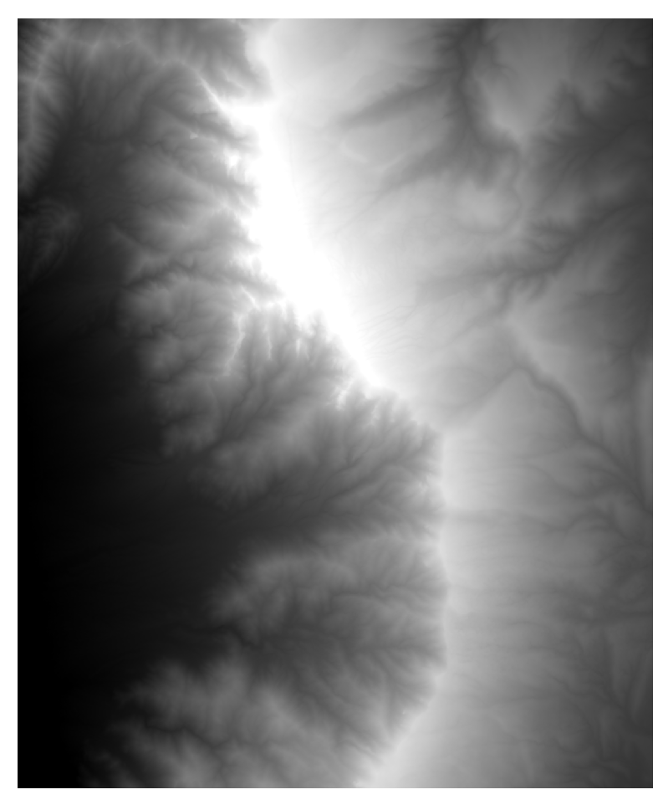

**Figure 1: Digital Elevation Model (DEM) QGIS Desktop**

1. Now you will learn about your dataset.
   1. **Open** the **Layer Properties** for the DEM and choose the **General** tab. Notice that the raster is in the **UTM** coordinate system. UTM has X/Y coordinate values in meters.
   2. Now switch to the **Metadata** tab. Notice that the **Pixel size** is 10 x 10. This means each cell represents a 10 by 10 meter area.
   3. Now switch to the **Style** tab. The elevation values (Z) of a DEM are typically either feet or meters. For me, the min value reads **1841** and the max value **3094**. Your values may differ slightly. By default, the **Load min/max values** is set to **Cumulative count cut** and the **Accuracy** is set to **Estimate (faster)**. Switch the **Load min/max values** to **Min/Max** and the **Accuracy** to **Actual (slower)** and **click** the **Load** button. The values should now read **1775** to **3255**. The [Sandia Mountain](http://en.wikipedia.org/wiki/Sandia_Mountains) range reaches 10,678 feet above sea level. Therefore, you can deduce that these elevation units are in meters. Before working with DEM’s it is important to understand what unit the X, Y and Z values are in. Here all three are in meters.
   4. **Close** the **Layer Properties** window.
2. **Save** your project as **Lab7.qgs**.
3. You will use the **Raster Terrain Analysis** plugin to create the three elevation related datasets. From the menu bar choose **Plugins 🡪 Manage and Install Plugins.** **Type** ‘***Terrain’*** into the **Search** bar. Find the **Raster Terrain Analysis plugin** and **click** the box to enable it. **Close** the **Plugins** window.
4. First you will create a hillshade image which will allow you to get a better feel for the terrain in this area. Hillshade images are very useful for creating nice maps of an area. From the menu bar choose **Raster 🡪 Terrain Analysis 🡪 Hillshade**. Use the following parameters (**Figure 2**).
   1. Elevation layer = **35106-B4**
   2. Output layer = **Lab 7/Data/MyData/Hillshade.img**
   3. Output format = **Erdas Imagine Images (.img)**
   4. Z factor – **1.0** (this is a conversion factor between the X/Y and Z units. Since all three are meters you can leave this at 1.0)
   5. **Check Add result to project**
   6. Leave defaults for Azimuth and Vertical angle (sun position).
   7. **Click OK.**
   8. When finished your map should resemble **Figure 3.**

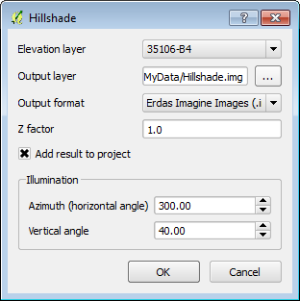

**Figure 2: Hillshade Parameters**

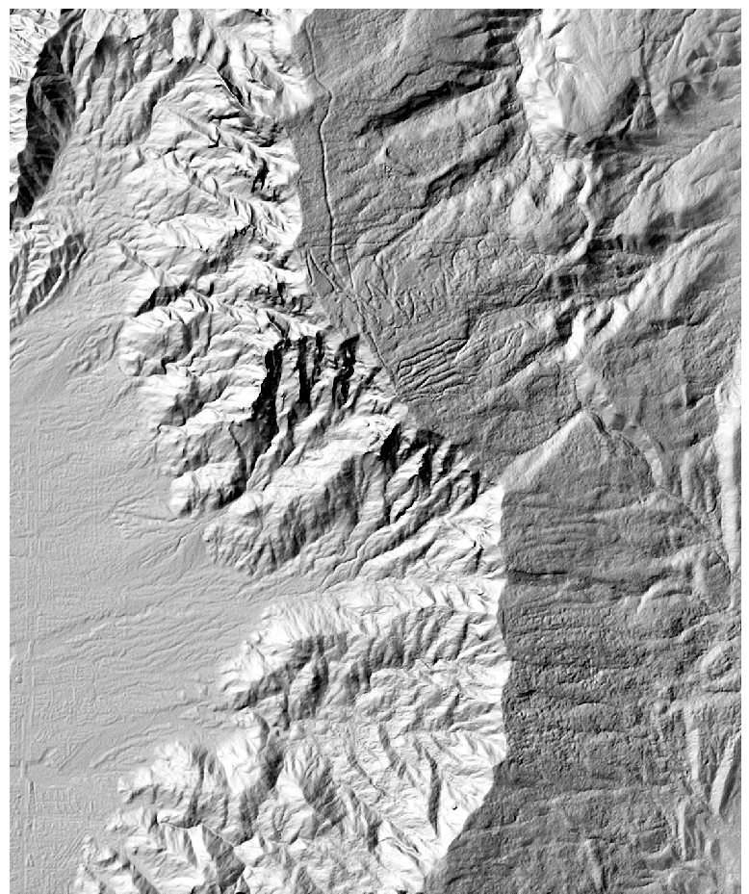

**Figure 3: Hillshade Layer**

This is a grayscale hillshade rendering. Now you will use both the original DEM and the hillshade to create a color hillshade image.

1. **Drag** the **Hillshade** below the **DEM** in the Table of Contents. **Open** the **Layer Properties 🡪** **Style** tab for the **DEM** (**35106-B4**) (**Figure 4**).
   1. Change the **Render type** to **Singleband pseudocolor**
   2. Change the color ramp to **BrBG**.
   3. Change the **Load min/max values** to **Min/max** and the **Accuracy** to **Actual (slower)**.
   4. **Click Classify**

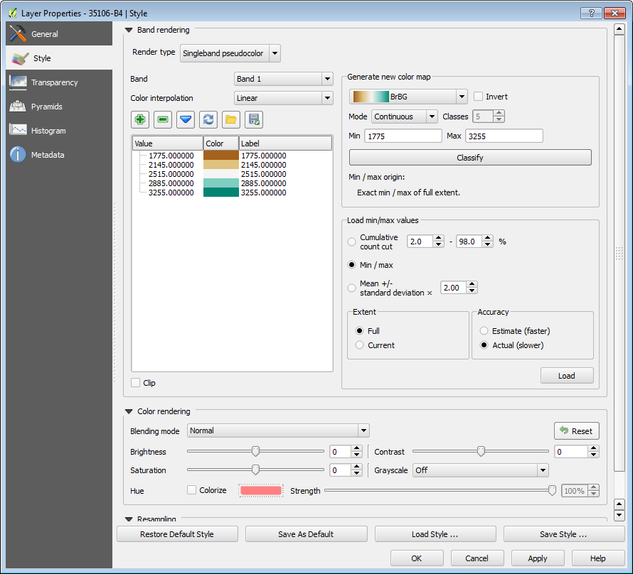

**Figure 4: Styling the DEM**

1. **Switch** to the **Transparency** tab and set the **Global transparency** to **50%**. **Click** **OK** and **close** the **Layer Properties**.
2. Your map should now resemble **Figure 5.**

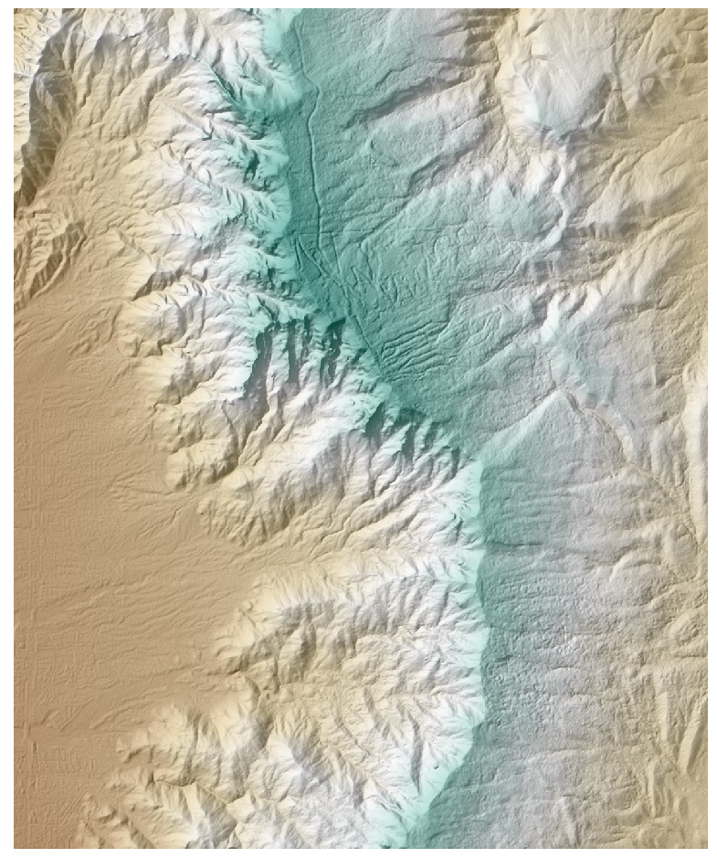

**Figure 5: Color Hillshade Image**

1. Now you will create a Slope dataset. From the menu bar choose **Raster 🡪 Terrain Analysis 🡪 Slope**. Fill out the **Slope** tool as shown in **Figure 6**.

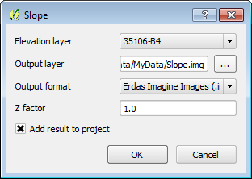

**Figure 6: Slope Tool**

The slope raster shows the steepest areas in white and the flattest terrain in black. The tool determines the steepness of each pixel by comparing the elevation value of each pixel to that of the eight surrounding pixels. The slope values are degrees of slope (**Figure 7**).

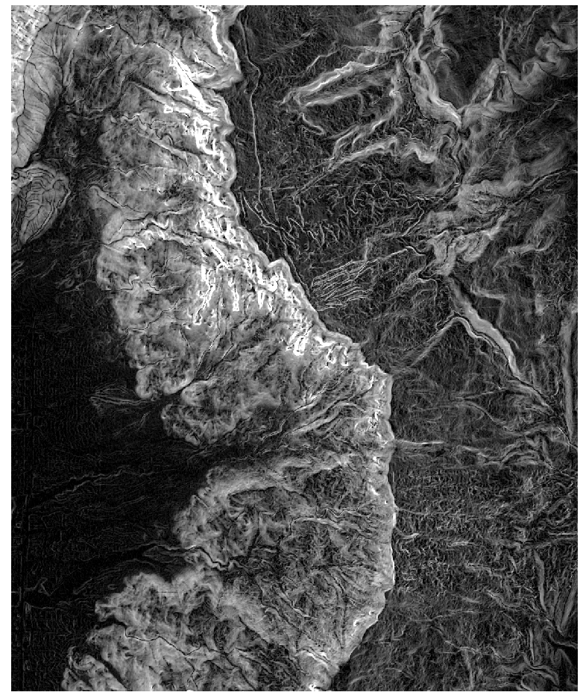

**Figure 7: Slope Raster**

1. Now you will create an Aspect dataset. Aspect measures which cardinal direction the terrain in each pixel is facing (north facing vs. south facing etc.) From the menu bar choose **Raster 🡪 Terrain Analysis 🡪 Aspect**. Fill out the **Aspect** tool with the **DEM** as the Elevation layer, name the output layer **Aspect.img**, save it to your **Lab 7/Data/MyData** folder and make the output format **Erdas Imagine Images (.img)**. **Click OK.** The output should resemble **Figure 8** with values ranging from ~0-360 representing degrees (0=north, 90= east, 180 = south and 270 = west)**.**

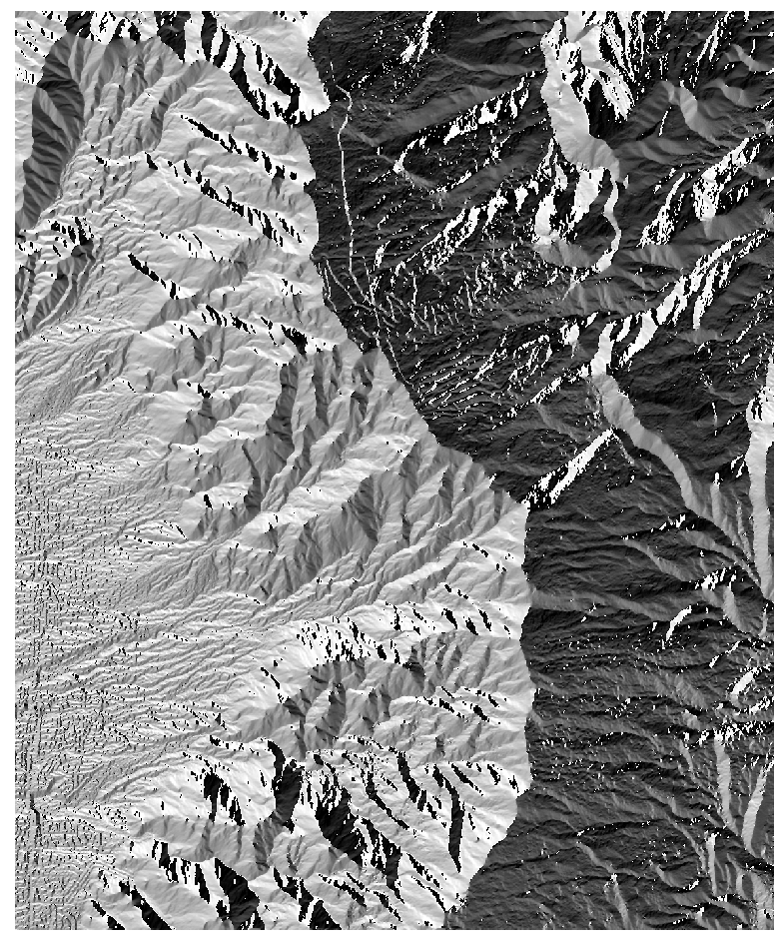

**Figure 8: Aspect Raster**

1. **Save** your project.
2. Reclassification

Now that you have created the slope and aspect data you will reclassify them into meaningful categories. Raster reclassification is a method for aggregating data values into categories. In this case, you will be reclassifying them into categories important to identifying habitat suitability for a plant. Once the slope and aspect data have been reclassified you will combine them in Task 3 to identify suitable habitat areas.

1. **Open QGIS Desktop 2.4.0** and open Lab 7/Data/**Lab6_Task2.qgs**
2. This plant requires steep slopes. You will classify slope raster into three categories: 0-45, 45-55, and > 55. First you will create a text file that contains the classification rules.
   1. **Open** **NotePad** or a similar text editor and create a text file with in the format of **Figure 9**.
   2. The first line tells QGIS to recode cells with slope values between 0 and 45 degrees with a new value of 1.
   3. Cells with slope values from 45-55 degrees will receive a new value of 2 and those cells with values greater than 55 will receive a new value of 3.
   4. **Save** the text file to the **Lab 7\Data\MyData** folder and name it **Slope_rRecode_Rules.txt**.



**Figure 9: Slope Classification Rules**

1. From the menu bar choose **Processing 🡪 Toolbox**. **Expand** the **GRASS commands** toolset **🡪 Raster (r.*) 🡪 r.recode - Recodes categorical raster maps**.
   1. Set the Input layer to **Slope**.
   2. Navigate to the Lab 7\Data\MyData folder and select the **Slope_rRecode_Rules.txt** as the **File containing recode rules.**
   3. **Name** the output file **Slope_ReCode.img (Figure 10).**
   4. **Click Run.**

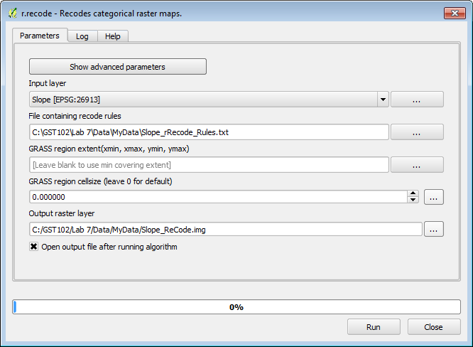

**Figure 10: r.recode Parameters**

1. The new layer will be called Output raster layer in the Table of Contents. It appears to have only two categories: 1) black and 2) white. **Open** the **Layer Properties 🡪 Style** tab.
   1. Change the Renderer type to **Singleband pseudocolor.**
   2. Change the color ramp to **RdYlGn**.
   3. Change the Mode to **Equal Interval**.
   4. Set the number of classes to **3**.
   5. Change the Load min/max values to **Min / max**.
   6. Change the Accuracy to **Actual (slower)**
   7. **Click Load**.
   8. **Click Classify.**
   9. Before closing Layer Properties go to the **General tab** and change the **Layer Name** to **Slope Reclassified.**
   10. **Close** the **Layer Properties.**
2. Now the best habitat in terms of slope has a value of 3 and the worst a value of 1 (**Figure 11**).

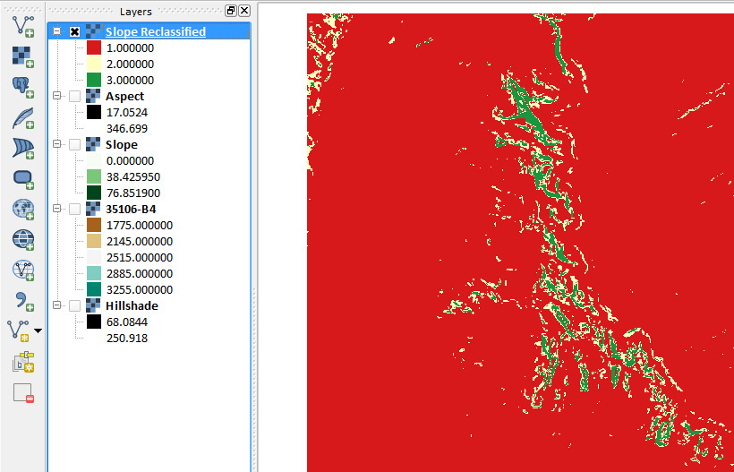

**Figure 11: Reclassified and Styled Slope**

Now you will recode the Aspect data in the same fashion. This plant prefers west facing slopes. Hence the west facing slopes will be set to 3, the north and south are the next best location so set them to 2, and the eastern slopes can be set 1. Remember that the values of the aspect raster are compass bearings or azimuths (270 is due west, 0 is north, 180 is south and 90 is east). You will classify the aspect data into eight cardinal directions.

1. **Open Notepad** and create a text file that looks like **Figure 12**. **Save** the text file to your **MyData** folder and name it **Aspect_rRecode_Rules.txt***.*

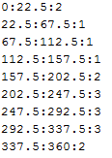

**Figure 12: Aspect Recode Rules**

1. From the menu bar choose **Processing 🡪 Toolbox**. **Expand** the **GRASS commands** toolset **🡪 Raster (r.*) 🡪 r.recode - Recodes categorical raster maps**.
   1. Set the **Input** **layer** to Aspect.
   2. Navigate to the **Lab 7\Data\MyData** folder and select the **Aspect_rRecode_Rules.txt** as the **File containing recode rules.**
   3. **Name** the output file **Slope_ReCode.img (Figure 13).**
   4. **Click Run.**

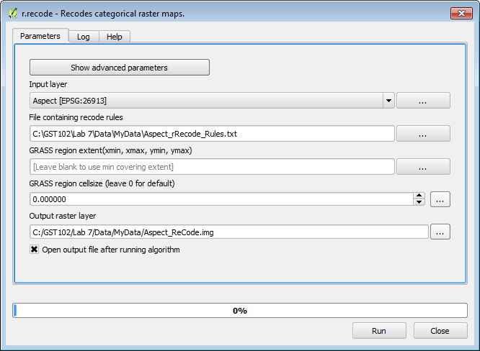

**Figure 13: r.recode Aspect Parameters**

1. **Save** you QGIS project.
2. Raster Calculator

Now you will use the Raster Calculator to combine the reclassified slope and aspect data. The Raster Calculator allows you to combine raster datasets mathematically to produce new outputs. For example raster datasets can be added, subtracted, multiplied and divided against one another. This procedure is also known as raster algebra. In this task you will add the two reclassified rasters together. Since each raster has ideal conditions coded with 3's, an area that ends up with a pixel value of 6 would be ideal.

1. **Open QGIS Desktop 2.4.0** and open Lab 7/Data/**Lab7.qgs**
2. From the menu bar choose **Raster 🡪 Raster Calculator.** The loaded raster datasets are listed in the upper right window. Below that there are a panel of operators and an expression window (**Figure 14**).
   1. **Double click** on **"Slope Reclassified@1"** to place it in the Raster calculator expression.
   2. **Click** the **addition** **sign**.
   3. Then **click** on the **"Aspect Reclassified@1" raster**.
   4. In the **Result layer** section name the output layer **Data/MyData/PlantHabitat.img.**
   5. Choose an Output format of **Erdas Imagine Images (*.img)**
   6. **Click OK.**

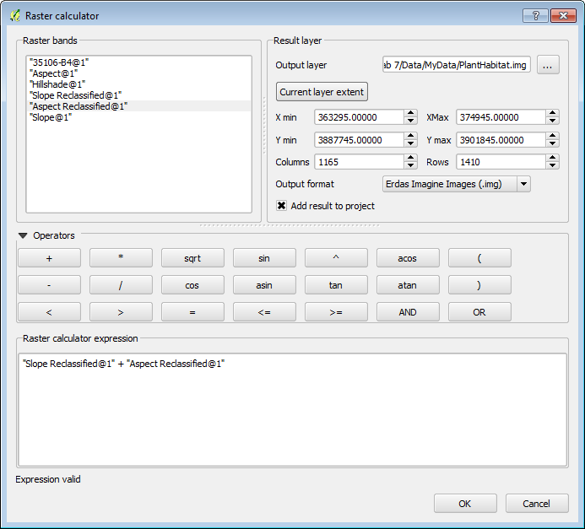

**Figure 14: Raster Calculator**

1. **Open** the **Layer Properties** and symbolize the data with 6 equal interval classes. This will be the same procedure you used in **Task 2 Step 4**.
2. The final map will resemble **Figure 15**.

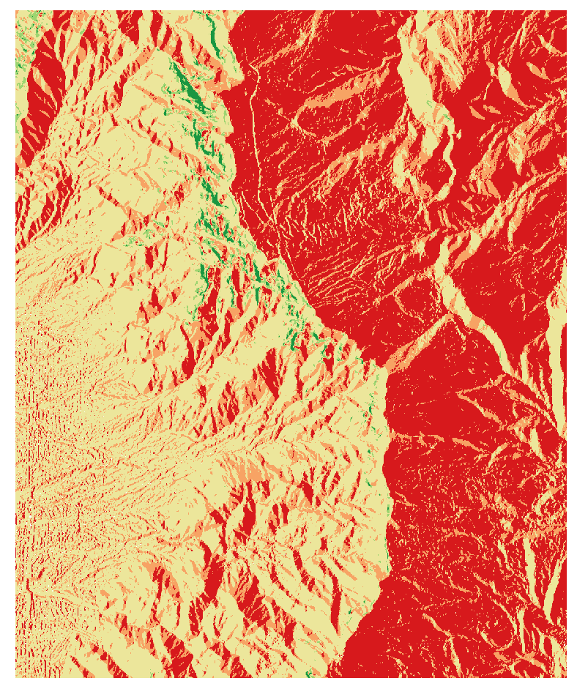

**Figure 15: Final Habitat Analysis**

5 Conclusion

In this lab, you were exposed to terrain analysis, creating derived datasets from elevation data (DEM's). You then went on to reclassify two terrain related datasets (aspect and slope), and combine them to produce a suitable habitat layer for a plant species. This is another method of doing site selection analysis. Raster data are well suited for these types of analyses.

6 Discussion Questions

1. What other real world applications of terrain analysis can you think of? Describe.
2. How does this suitability analysis compare to the site selection analysis done with the vector data model in Lab 5?
3. What other linear networks could this apply to other than roads?

7 Challenge Assignment

Another scientist is interested in developing a map of potential habitat for another species that prefers rugged, steep west facing slopes. Use the **Raster Terrain Analysis plugin** to develop a **Ruggedness Index**. Recode the Ruggedness Index into three categories:

0:20:1

20:40:2

40:*:3

Combine the resulting recoded ruggedness index with the recoded slope and aspect from the lab to create the final result. Compose a map showing the results.